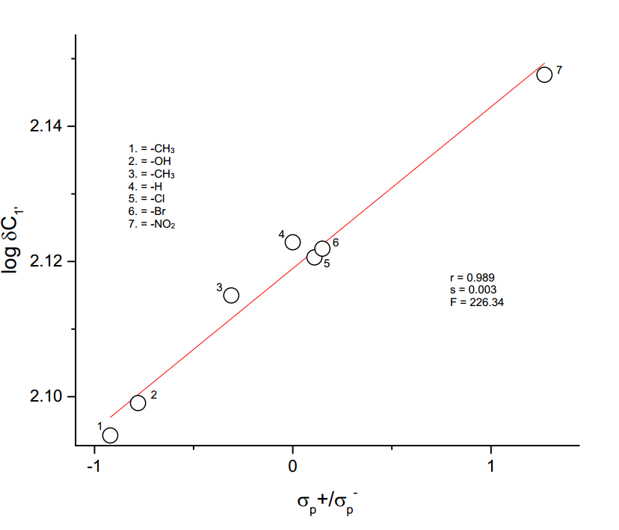

**Figure 3.7** The plot of log δ C1′  vs σp+ / σp-